Considera el alfabeto en Inglés (26 caracteres)

7

Factor múltiplicativo

1

7

Corrimiento (aditivo)

|  |  |  |  |  |  |  |  |  |  |  |  |  |  |  |  |  |  |  |  |  |  |  |  |  |  |  |
| --- | --- | --- | --- | --- | --- | --- | --- | --- | --- | --- | --- | --- | --- | --- | --- | --- | --- | --- | --- | --- | --- | --- | --- | --- | --- | --- |
| Alfabeto | a | b | c | d | e | f | g | h | i | j | k | l | m | n | o | p | q | r | s | t | u | v | w | x | y | Z |
| Número | 0 | 1 | 2 | 3 | 4 | 5 | 6 | 7 | 8 | 9 | 1  0 | 1  1 | 1  2 | 1  3 | 1  4 | 1  5 | 1  6 | 1  7 | 1  8 | 1  9 | 2  0 | 2  1 | 2  2 | 2  3 | 2  4 | 2  5 |
| Resultado de la transformación | 1  7 | 2  4 | 5 | 1  2 | 1  9 | 0 | 7 | 1  4 | 2  1 | 2 | 9 | 1  6 | 2  3 | 4 | 1  1 | 1  8 | 2  5 | 6 | 1  3 | 2  0 | 1 | 8 | 1  5 | 2  2 | 3 | 1  0 |
| Letra correspondiente | R | Y | F | M | T | A | H | O | V | C | J | Q | X | E | L | S | Z | G | N | U | B | I | P | W | D | K |

Ejercicio 1

|  |  |  |  |  |  |  |  |  |  |  |  |  |  |  |  |  |  |
| --- | --- | --- | --- | --- | --- | --- | --- | --- | --- | --- | --- | --- | --- | --- | --- | --- | --- |
| Message . | c | r | y | p | t | o | g | r | a | p | h | y | c | l | a | s | s |
| Ciphertex  t | **F** | **G** | **D** | **S** | **U** | **L** | **H** | **G** | **R** | **S** | **O** | **D** | **F** | **Q** | **R** | **N** | **N** |

3

Factor múltiplicativo

2

Corrimiento (aditivo)

|  |  |  |  |  |  |  |  |  |  |  |  |  |  |  |  |  |  |  |  |  |  |  |  |  |  |  |
| --- | --- | --- | --- | --- | --- | --- | --- | --- | --- | --- | --- | --- | --- | --- | --- | --- | --- | --- | --- | --- | --- | --- | --- | --- | --- | --- |
| Alfabeto | a | b | c | d | e | f | g | h | i | j | k | l | m | n | o | p | q | r | s | t | u | v | w | x | y | Z |
| Número | 0 | 1 | 2 | 3 | 4 | 5 | 6 | 7 | 8 | 9 | 1  0 | 1  1 | 1  2 | 1  3 | 1  4 | 1  5 | 1  6 | 1  7 | 1  8 | 1  9 | 2  0 | 2  1 | 2  2 | 2  3 | 2  4 | 2  5 |
| Resultado de la transformación | 2 | 5 | 8 | 11 | 14 | 17 | 20 | 23 | 0 | 3 | 6 | 9 | 12 | 15 | 18 | 21 | 24 | 1 | 4 | 7 | 10 | 13 | 16 | 19 | 22 | 25 |
| Letra correspondiente | C | F | I | L | O | R | U | X | A | D | G | J | M | P | S | V | Y | B | E | H | K | N | Q | T | W | Z |

|  |  |  |  |  |  |  |  |  |  |  |  |  |  |  |  |  |  |
| --- | --- | --- | --- | --- | --- | --- | --- | --- | --- | --- | --- | --- | --- | --- | --- | --- | --- |
| Message . | c | r | y | p | t | o | g | r | a | p | h | y | c | l | a | s | s |
| Ciphertex  t | **I** | B | W | V | H | S | U | B | C | V | X | W | I | J | C | E | E |

Ejercicio 2

2

Factor múltiplicativo

5

Corrimiento (aditivo)

|  |  |  |  |  |  |  |  |  |  |  |  |  |  |  |  |  |  |  |  |  |  |  |  |  |  |  |
| --- | --- | --- | --- | --- | --- | --- | --- | --- | --- | --- | --- | --- | --- | --- | --- | --- | --- | --- | --- | --- | --- | --- | --- | --- | --- | --- |
| Alfabeto | a | b | c | d | e | f | g | h | i | j | k | l | m | n | o | p | q | r | s | t | u | v | w | x | y | Z |
| Número | 0 | 1 | 2 | 3 | 4 | 5 | 6 | 7 | 8 | 9 | 1  0 | 1  1 | 1  2 | 1  3 | 1  4 | 1  5 | 1  6 | 1  7 | 1  8 | 1  9 | 2  0 | 2  1 | 2  2 | 2  3 | 2  4 | 2  5 |
| Resultado de la transformación | 5 | 7 | 9 | 11 | 13 | 15 | 17 | 19 | 21 | 23 | 25 | 1 | 3 | 5 | 7 | 9 | 11 | 13 | 15 | 17 | 19 | 21 | 23 | 25 | 1 | 3 |
| Letra correspondiente | F | H | J | L | N | P | R | T | V | X | Z | B | D | F | H | J | L | N | P | R | T | V | X | Z | B | D |

|  |  |  |  |  |  |  |  |  |  |  |  |  |  |  |  |  |  |
| --- | --- | --- | --- | --- | --- | --- | --- | --- | --- | --- | --- | --- | --- | --- | --- | --- | --- |
| Message . | c | r | y | p | t | o | g | r | a | p | h | y | c | l | a | s | s |
| Ciphertex  t | J | N | B | J | T | H | R | N | F | J | T | B | J | B | F | P | P |

Nota: Los procedimientos deben realizarse a mano, debes escanear tus notas o tomar una foto e incluirla como imagen al final de este archivo.

Trabajos sin procedimientos a mano valen 0 puntos.

Al finalizar guarda tu archivo como PDF para subirlo a Classroom.

Procedimientos:

-Chacón Inostrosa Jaime Enrique:

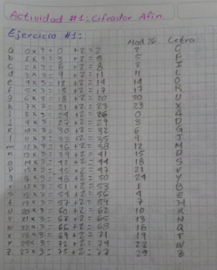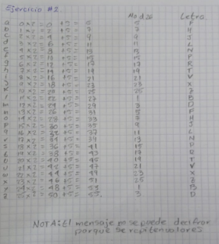

-Sánchez Méndez Edmundo Josué:

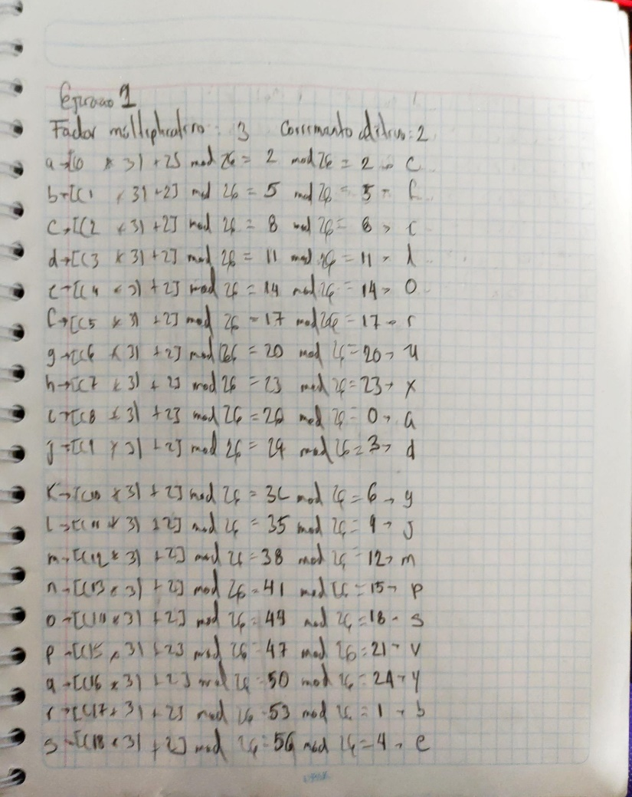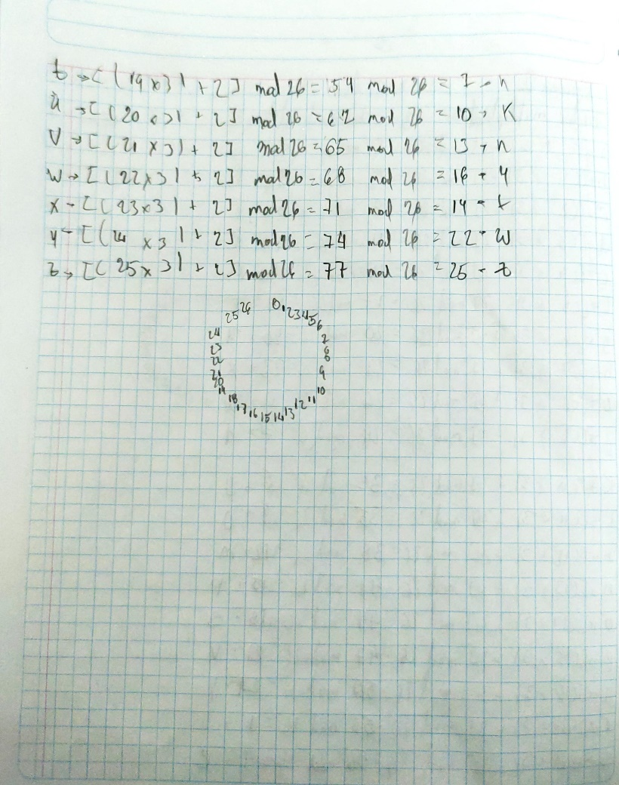

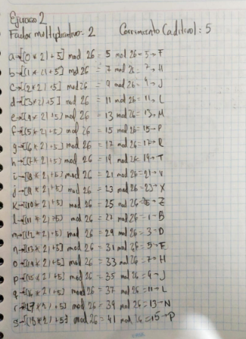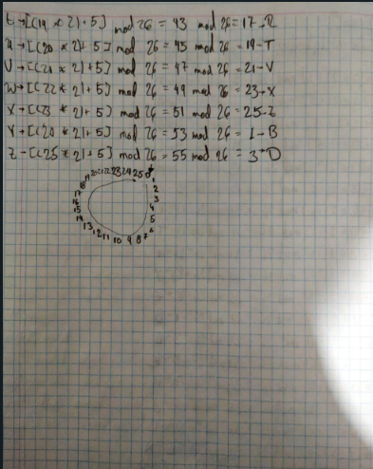

-Ramírez Olvera Guillermo:

